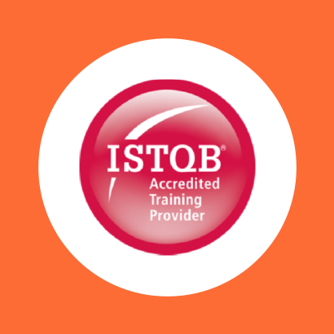

COURSE OUTLINE

Course Name: ISTQB Agile Testing Foundation Level

|  |  |  |  |  |
| --- | --- | --- | --- | --- |
| **DURATION** | **SKILL LEVEL** | **DELIVERY**  **METHOD** | **TRAINING**  **CREDITS** | **TECHNOLOGY** |
| 2 Day(s) | Foundation | In Class/ VITL | N/A | ISTQB |

**Course Overview**

This course provides candidates with the knowledge of testing activities and roles in Agile development teams. It identifies testing interventions supporting Agile methods and how testers can add value through these interventions. Candidates are introduced to the concept of a proactive attitude, delivering testing and the ownership of quality. test design techniques, and specifying test cases to evaluate software characteristics.

**Prerequisite**

Candidates wishing to take the ISTQB Advanced Technical Test Analyst Certificate must hold the ISTQB Foundation Certificate or ISTQB Certified Tester Foundation Level Certificate. There are certain work experience prerequisites, a document

**Audience**

The course is of interest to Testers, Developers, Business Analysts and Test Managers who are venturing into the world of Agile or and wishing to progress.

**Topics**

The course covers the following areas:

* Introducing Agile, Extreme Programming (XP) and SCRUM (these will form the backbone of the course
* Levels of Testing in Agile:
* Iteration
* Integration (regression)
* User stories – defining “done”
* User stories – estimating test effort
* Quality criteria and owning quality
* Demonstrations as “tests”
* Integration – testing the iterations, release and regression coverage
* Defect tracking in Agile using the SCRUM board
* Attitude – being a member of an Agile team• Helping developers with tests, helping product owners with “done”

**Exams and Certifications**

No associated Exams. A Certificate of completion is issued at the end of the Course.

**Notes and Annotations**

Not Any

Shape

**What is Next**

Art of communication